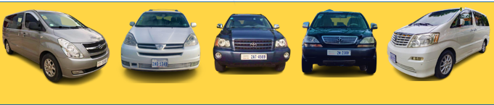
Toyota Alphard van 6-seater
Toyota Sienna Van 6-seater
Hyundai Van 8-seater
SUV 4-seater

